**ASSIGNMENT**

**IPv4 and IPv6:**

The address through which any computer is able to communicate with our computer is called as INTERNET PROTOCOL ADDRESS or IP address. It is of two types:

* IPv4
* IPv6

**IPv4 (version 4):**

* It consists of two tings network address and host address.
* IPv4 addresses are 32 bit integers which are represented in decimal notation.
* It is represented in the form of 4 numbers separated by dots which are in the range of 0-255.
* These are then converted in the form of 0’s and 1’s.
* IPv4 address format: 128.3.11.31

**IPv6 (version 6):**

* IPv6 is better than IPv4 in terms of efficiency.
* It is represented in the form of 8 hexadecimal numbers separated by semicolon.
* Address format:

ABCD: EF01: 2345: 6789: ABCD: B201: 5482: D023

* IPv6 has greater advantages like large address space, improved security and improved support for mobile devices.

**IP addressing schemes**

IPv4 addressing scheme:

* Class A: First octet defines network and rest define host

(e.g. 10.0.0.1)

* Class B: First two octets define network and rest define host (e.g. 172.16.0.1)
* Class C: First three octets define network and rest define host (e.g. 192.168.0.1)
* Class D: Used for multicasting
* Class E: Reserved for future use

IPv6 addressing scheme:

* IPv6 addresses are divided into three parts: the prefix, the subnet ID, and the interface ID.
* The prefix is used to identify the network, the subnet ID is used to identify subnets within the network, and the interface ID is used to identify the device.

**Difference between IPv4 and IPv6:**

|  |  |
| --- | --- |
| **IPv4** | **IPv6** |
| IPv4 has a 32-bit address length | IPv6 has a 128-bit address length |
| In IPv4 end to end, connection integrity is Unachievable | In IPv6 end-to-end, connection integrity is Achievable |
| Address representation of IPv4 is in decimal | Address Representation of IPv6 is in hexadecimal |
| IPv4 can be converted to IPv6 | Not all IPv6 can be converted to IPv4 |

**Reserved ports**

* Port numbers can run from 0 to 65353.
* Port numbers from 0 to 1023 are reserved for common TCP/IP applications and are called *well-known ports*.
* The use of well-known ports allows client applications to easily locate the corresponding server application processes on other hosts.

Well-known vs Registered:

* Well-known ports range from 0-1023 and are standardized for commonly used applications.
* Registered ports range from 1024-49151 and are for less commonly used applications.

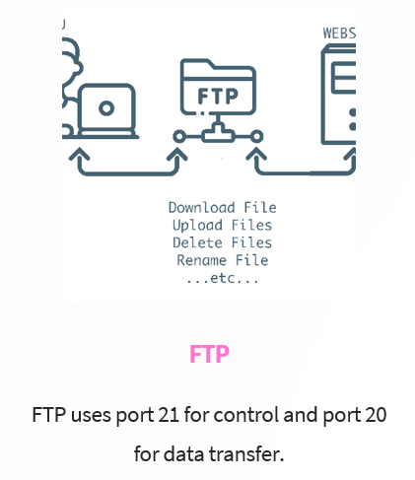**APPLICATIONS USING RESERVE SPOTS:**

